Genetic Spin – Spin City – PsyTropic Records

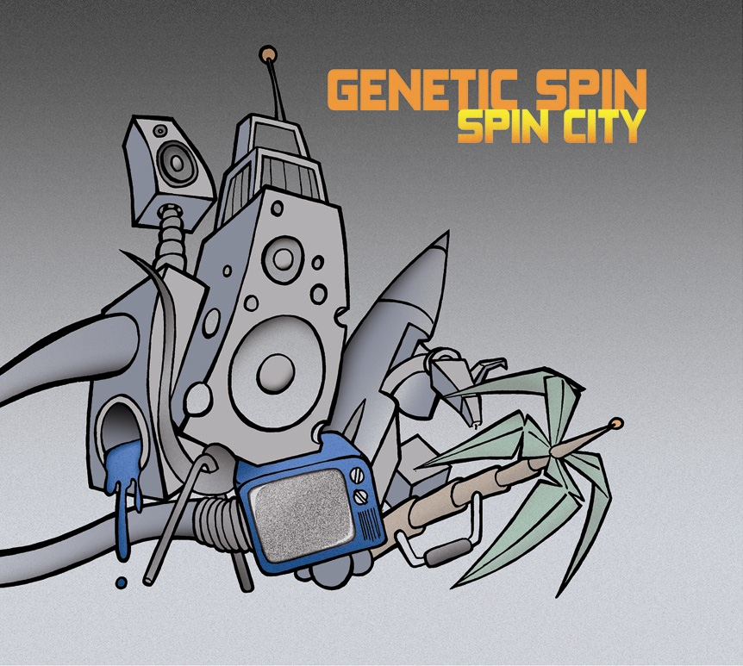 |  | RELEASE NOTES  “Spin City” is Genetic Spin’s 3rd studio album out on PsyTropic Records.  After two full years from the last album “Backspin” Genetic Spin strikes back much stronger than ever in the past. The listener will feel a mind-blowing and pure quality power inside each of the nine tracks. Every track shows sensitive maturity and accuracy in choosing sounds, elements and ingredients for story-telling. Furthermore it is a nice blend of different kinds of stories – which allows travelling highly from vocalised progressive tracks or morning stomping tracks to the point of gloomy full-on tracks and forward-pushing morning tunes. The listener will feel the diversity of Genetic Spin and its emotional power.  “Spin City” is a new meaning to so-called Progressive Trance and Full-On with freshness and atmosphere for homelistening, car rides and at last and most of all for the dancefloor.  It is not a secret anymore that this album will surprise you and last in your mind for a long time.  Label Profile:  PsyTropic Records has proved its flexibility and open-mindedness through compilations they have released in the past. There was always something special about it - the mixture of several styles within the category “PsyTrance”. PsyTropic Records broke the boundaries to specify stylenames such as dark fullon, melodic morning, progressive and neo-fullon by unifying all those named styles in one Release. In the end it is always the taste to be a part of something extraordinary and while recognizing that fact, one becomes special and contented.  Artist Profile:  Genetic Spin is Michael Schultz from Denmark. He is born in 1980 and he has been living in Copenhagen his whole life.  In the year 2000 “Genetic Spin” enters the psytrance scene from which it shows its flexibility and purity in making different tracks with a sure sense of style.  Since 2000 Genetic Spin released 2 Studio Albums “On-Off” (Creamcrop Records), “Backspin” (Nervine Records) and a single called “Lowrider” (Creamcrop Records).  Beside the studio albums Genetic Spin released about 37 tracks in more than 19 different Labels until now.
Title: | Spin City
Artist: | Genetic Spin
Label: | PsyTropic Records
Catalogue: | PTRCD006
Format: | 4-Panel Digipak Audio CD
Barcode:
Release: | November 24th, 2006
Tracklist

1. Desperate House Beats (140 BPM)
2. The Fridge (142 BPM)
3. Hybrid (144 BPM)
4. Lord of the Strings (2006 Rmx)(140 BPM)
5. Shoplifting (142 BPM)
6. Spin City (145 BPM)
7. Memotech (143 BPM)
8. Monkey Business (142 BPM)
9. No Idea (140 BPM)

CREDITS
Mastered by Son Kite
Artwork by J. Skovsted & F. Trampe
Distribution by Arabesque
(p) and © PsyTropic Records
http://www.PsyTropic-Records.com
Chemicus@gmx.com



