Principles Of Flight - Chaos Opera
Timecode Records - TCCD026
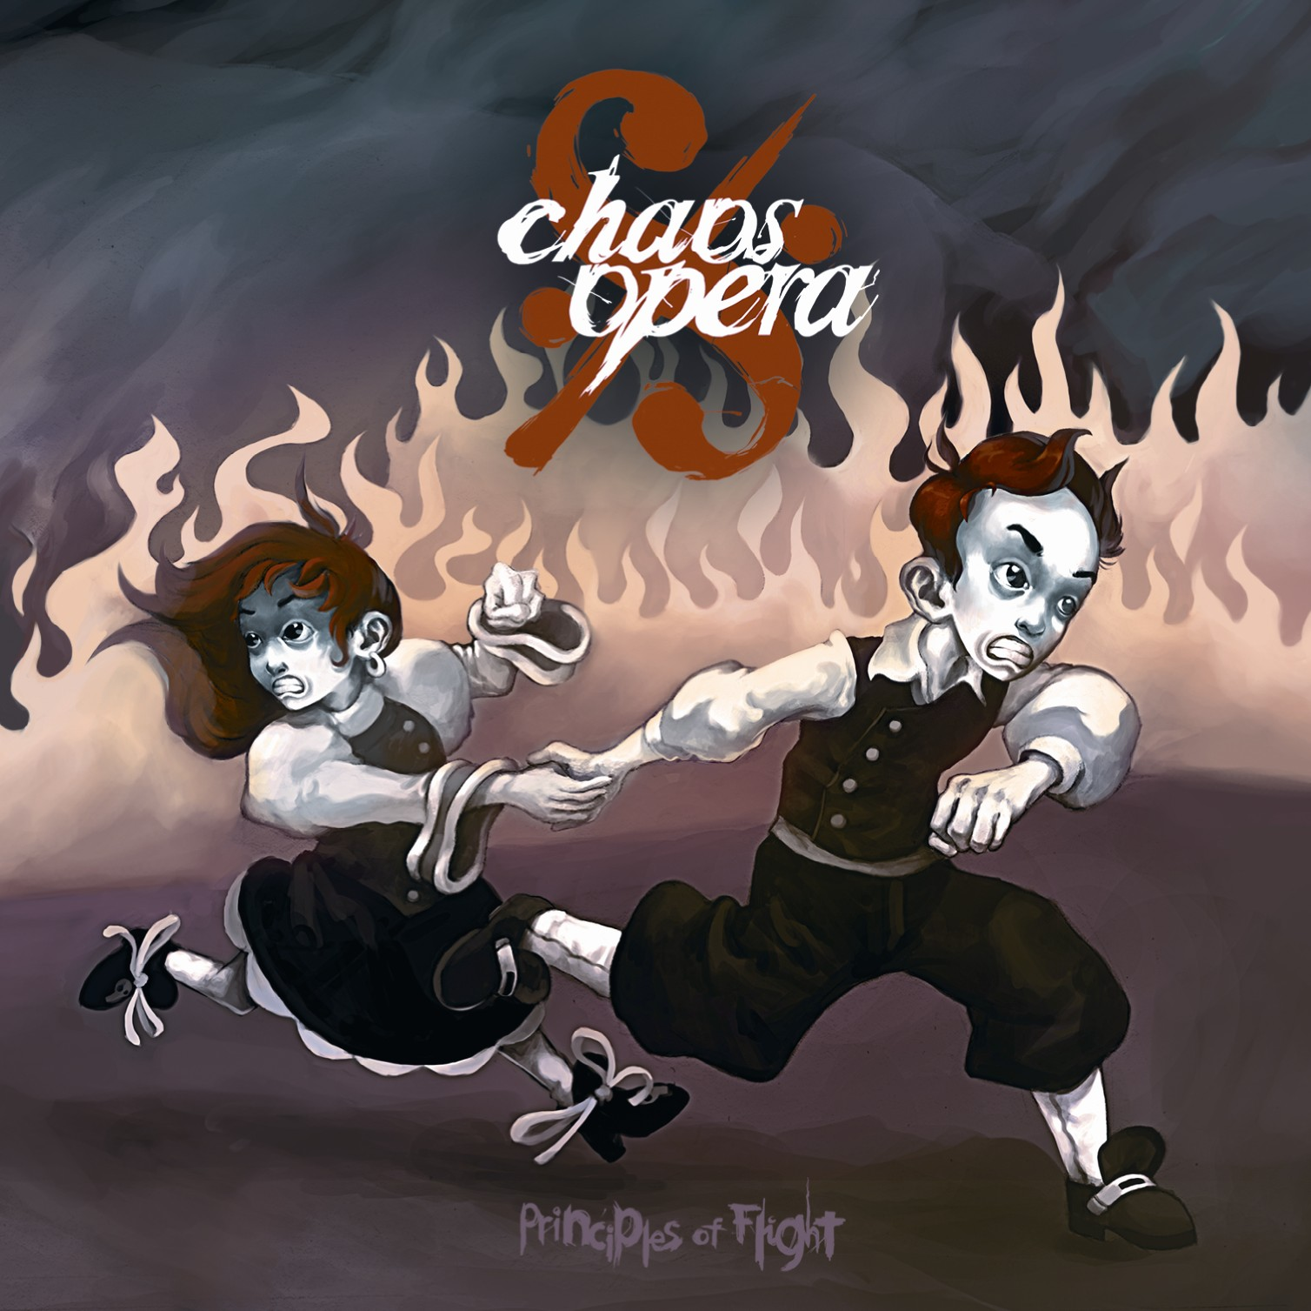

Artist: Principles Of Flight
Title: Chaos Opera
Label: Timecode Records
Cat No: TCCD026
Barcode: 6009689370668
Format: 6 panel digipak with
24 page story book

Release date: 24 April 2008

Distribution: Worldwide Distribution by
Saiko Sounds Ltd
Website: www.saikosounds.com

"Once upon a time in a far distant land, a land where the only colors of life were black and white, a land where laughs and smiles were forbidden and where clowns were sent to dungeons, a land where life had to obey strict rules and where amusement was controlled by a militia, lived a little girl, Eleanor."
Timecode presents the bright new spark of the psychedelic night scene: Principles of Flight. After the worldwide acclaim for their first album, Night Time Lullabies (2006 BooM! Records), Principles of Flight have decided to further explore the idea behind this release, and work on an extraordinary concept album entitled Chaos Opera.

Remy, 24, and Pierre, 26, have developed a unique blend of tech-trance rhythms, psychedelic groove, and night time landscapes which can best be described as "psytechno", and which has been praised by trancers around the world. As new ambassador of the prestigious South African label Timecode, Principles of Flight have reached an incredible level of production and composed a true masterpiece that goes far beyond just music.

With almost two years of intensive design, Chaos Opera is far more mature than its predecessor. It tells the story of Eleanor and Edward, two twins living in a colorless world, and the incredible journey, which Edward undertakes to look for his sister in the Land of the Dead. A whole world came out of the imaginations of Pierre, Remy, and Nicolas Delort, the artist behind Chaos Opera's visual universe.

Chaos Opera comes in a luxury digipak triptych with a virtuoustically illustrated 24 page booklet which contains both English and Japanese translations of Pierre Delort's original Chaos Opera story.

01. Into the Lands of Black & White
02. Chaos Opera
03. The Queen of the Dead
04. Elenor’sTheme
05. Cerebus
06. Charon the Ferryman
07. The Tavern, the Rebels, & the Secret Oath
08. A Gruesome Plan
09. The Black Mass
10. Edward to the Rescue
11. The Chase
12. A Colourful End

