ATMA “Beyond Good & Evil” CD – Geomagnetic.tv

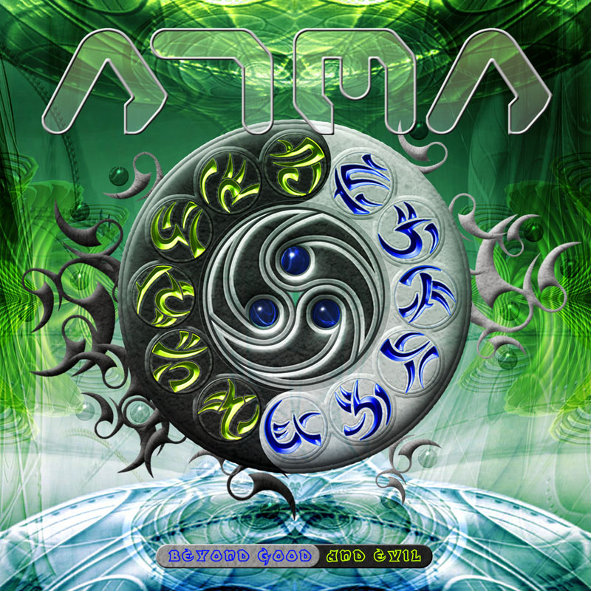 |  | RELEASE NOTES  “Beyond Good & Evil”, the new ATMA album represents  a new step in the evolution of psy trance culture, a perfect mixture between music and philosophy.  Build up as a complete story, this album it is a real portal, a star gate, to another world.  “We will rise again”, this is the overall positive message of the album!!! With this message, Atma’s music will open the doors of perception, giving you, a one way ticket to the other side.  -Take a good listen & find the right key to access the portal and pass beyond good & evil!!!  The result of almost 3 years of studio work, this album has a large musical spectrum... (From deep melody to twisted sounds, from electronic sound effects to pianos & violins & from pumping full on bass lines to old school goa line).  Label Profile:  Geomagnetic.tv was established in the summer of 2001.  Their first major international release is the legendary DVD  project “MAGNUS” geodvd001. Since then they have added 30 label artists and have multitudes of projects in the works for 2006 and beyond. Based in San Francisco  and focusing mostly on visual and music related projects,  you can expect to see lots more cutting edge releases on the way from this award winning crew! Geomagnetic.tv was started by Spook one of the founders of the prominent San Francisco 3D FX and Multimedia boutique known as Minds Eye Media (est.1995). www.mindseyemedia.com  Artist Profile:  Andrei Oliver Brasovean aka “ATMA” is original from Transylvania\ Romania.  Starting to produce techno and trance music since 1992, he is one of the pioneers of electronic music in East Europe.  In ’95-’96 he started to produce Goa trance music and to organise small parties. In almost 14 years of electronic music  Production, Atma played under different names and different colaborations like: Atma & R’tur, Ravana, Lunatic Asylum, Raving Minds, Andy Hype, Atma & Styx, Jedi Atma...  He has also several releases on labels like: Ov-Silence, Skills rec, Roton, Yellow Sunshine Exposion, Media Services (Sony Music), Cytopia Rec, Sith Rec, Dreamtime Rec…  Beside his trance projects, Atma works as music composer & sound engineer for commercial bands (house, techno, dance, pop, rock, hip hop..) and also as a film music producer, theatre & orchestral arrangments.  On the international sceen he played at festivals and parties all arownd Europe: Germany, Swiss, Austria, Bulgaria, Romania… near artists like: Eat Static, X Dream, Bamboo Forest, BLT, Commercial Hippies, Haldolium…
Title: | ATMA – Beyond Good & Evil
Artist: | ATMA
Label: | Geomagnetic.tv
Catalogue: | GEOCD017
Format: | 4-Panel Digipak Audio CD
Barcode:
Release: | September 25th World Wide
TRACK LIST
1. We will rise again 7:54
2. Beyond Good & Evil 7:40
3. The Other Side 7:39
4. Deviant Behaviour 8:19
5. The Ganzfeld Experiment 8:11
6. The Doors Of Perception 7:56
7. Psychedelic Visionars 7:58
8. Eternal Cycles 8:31
9. There is still hope 7:38

CREDITS
Mastered by Chromatone Waveworks
Engineering by Random
Artwork by Miro Moric aka Sketch Inc
Distribution by Saiko Sounds / File Rec
(p) and © Geomagnetic.tv
http://geomagnetic.tv/releases/ATMA-BeyondGoodAndEvil.htm
info@geomagnetic.tv Hi-Res art online.


