BODHISATTVA 1320: Secrets of The Mojave CD – Geomagnetic.tv

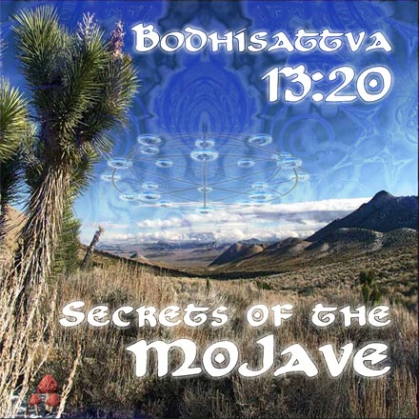 |  | RELEASE NOTES  Bodhi's new album - "Secrets of the Mojave" sets a new standard in twisted full-on night time trance music. He has refined his sound once again and produced "these" pristine ultra frequency laden mega killas. From beginning to end his sound will wrap you up in its deep enveloping blissful serenity while at the same time drive you into uncontrollable fits of dance floor mayhem. "This record is dedicated to all that lies hidden and unknown within the Mojave Desert- the birthplace of Bodhi's psytrance career." Prepare to be treated to a high fidelity finely tuned excursion through the heights and depths of spirit of the Mojave Desert.  Label Profile:  Geomagnetic.tv was established in the summer of 2001.  Their first major international release is the legendary DVD  project “MAGNUS” geodvd001. Since then they have added 30 label artists and have multitudes of projects in the works for 2006 and beyond. Based in San Francisco  and focusing mostly on visual and music related projects,  you can expect to see lots more cutting edge releases on the way from this award winning crew! Geomagnetic.tv was started by Spook one of the founders of the prominent San Francisco 3D FX and Multimedia boutique known as Minds Eye Media (est.1995). www.mindseyemedia.com  Artist Profile:  Message from Bodhisattva 1320 -  “ Greetings, I am the Bodhisattva of the 13 moons and the 20 suns. I am here to guide those interested into the abyss of the conscious and subconscious self by means of sonic frequencies. With the right combination of sound, the soul can easily transcend within and shape a more focused and optimistic being here on earth. Only a curious being with an open mind can achieve this. Collectively, the sonic manipulations presented on this disc have been designed to help those fortunate individuals by guiding them towards transcendence and enlightenment.  The Mojave Desert in southern California is one of the youngest deserts in the world. Just at the end of the last ice age, it was a land of lakes and forests, which has all dried up leaving mysterious caves, remnants of ancient civilizations, strange plants and animals, crystals and minerals, and many secrets. The dryness and extreme temperature changes promote purification and healing. This is the perfect place for a sacred all-night trance, psychedelic style. Presented here on this album are electronic compositions perfect for this scenario, all sequenced at 146 BPM.  Love, Light, Knowledge, Integration, Evolution, back to Zero.  ~Bodhi”  Bodhisattva 13:20 has released killer tracks on these other International compilations/Albums:TRUFFLE RECORDS- SOLAR FLARES TRUFFLE RECORDS - BODHI SATTVA ARTIST ALBUM - EXCURSIONS PSYBERTRIBE REC- DIGITAL SHAMAN GEOMAGNETIC.TV REC- WELLSPRING VERTIGO REC.-link coming soon COSMICTHEATRE REC.-link coming soon  MIGHTY QUINN REC.-link coming soon
Title: | Bodhisattva 1320 – Secrets of the Mojave
Artist: | BODHISATTVA Artist Album
Label: | Geomagnetic.tv
Catalogue: | GEOCD007
Format: | 4-Panel Digipak Audio CD
Barcode: | 9366977745094
Release: | July 12th World Wide
TRACK LIST
1. Pineal Erethism
2. Ixtlan Winds
3. Gravitron Deflector
4. Sheen Peter
5. Thought Invasion
6. Nocturnal Trancendance
7. Patient Tolerance
8. Calculation Malfunction
9. Giggle Gargle
10. Wave Functions

CREDITS
Mastered by Chromatone Waveworks
Engineering by Random
Artwork by Doctor Spook
Distribution by Saiko Sounds / File Rec
(p) and © Geomagnetic.tv
http://www.geomagnetic.tv/releases/Bodhisattva_SecretsOfTheMojave.htm
info@geomagnetic.tv Hi-Res art online.


