CIVILYSED CHAOS (GEO – ISRAEL) a Division of Geomagnetic.tv

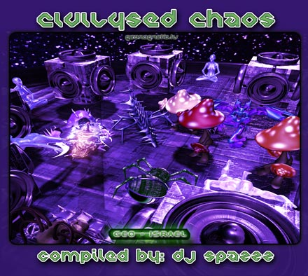 |  | RELEASE NOTES:  Civilysed Chaos debuts the new GEO-ISRAEL branch in a big way! Brought to you by international dj extrodinaire DJ SPAZZZ known for delivering uncompromising unreleased dj sets all over the globe, recently back from his tour in Japan! Now he returns to Israel to present the hottest acts coming from Israel, Mexico and Switzerland, this collection of twisted mind bending mental blasters delivers and then some. Spazzz is honored to present the leaders of the Israel Underground Psy scene to kick off this new Geo Israel branch right!  Label Profile:  Geomagnetic.tv was established in the summer of 2001.  Their first major international release is the legendary DVD  project “MAGNUS” geodvd001. Since then they have added 30 label artists and have multitudes of projects in the works for 2006 and beyond. Based in San Francisco  and focusing mostly on visual and music related projects,  you can expect to see lots more cutting edge releases on the way from this award winning crew! Geomagnetic.tv was started by Spook one of the founders of the prominent San Francisco 3D FX and Multimedia boutique known as Minds Eye Media (est.1995). www.mindseyemedia.com  Artist Profile:  AVIV MIZRAHI is a gifted DJ and PSY-PRODUCER from TelAviv Israel. He started Listening to trance in 1992 and has never stopped since, fully immersing himself until he took the next step after finding his now life consuming passion. In 2000 Spazzz began making events cantered around psytrance and also began DJing around this era as well. Since then he has played all over Israel and Japan spreading his favorite music. In 2005 Spazzz met dj Doctor Spook and now he is appointed the honorable and coveted position as Sub - Label Manager of Geo - Israel. He started collaborating on tracks late in 2005 and now has a track coming out on TRIP CONTROLLERS V/A compilation as well as a collaborative project included on this compilation as well. His new comp CIVILYSED CHAOS will be available on the world market early spring 06.  Online Promotional Thread:  http://forum.isratrance.com/viewtopic.php/topic/80874/forum/41
Title: | CIVILYSED CHAOS
Artist: | V/A compiled By DJ SPAZZZ
Label: | Geo - Israel
Catalogue: | GEOCD009
Format: | 4-Panel Digipak Audio CD
Barcode: | 9366977745162
Release: | June 2006 World Wide
TRACK LIST
1. Guinea Pigs - How To Get By in The U.S.
2. Dark Force - Cow Hypnosis
3. Energy Loop - Like a Walk in The Park
4. Audiopathik - Speak of the Devil
5. Clockstoppers - Room Function
6. Pz2 (Electrypnose vs Zapata vs Elendil) - Des Trip Laids
7. Dark Force and Spazzz - Darkenss and the Spirit
8. Electrypnose vs Energy Loop - Dont Kill Me
9. Darknoize - Lost Pick Up (Tsabeat vs Energy Loop)
10. Mindstorm vs Twisted Reaction - Civilysergia
CREDITS
Mastered by Chromatone Waveworks
Engineering by Random
Artwork by Doctor Spook
Distribution by Psyshop
(p) and © GEO - ISRAEL a division of Geomagnetic Records
http://geomagnetic.tv/releases/CivilysedChaos.htm Hi-Res art online.



