Cybervixen Artist Album – Kundal My Lini – Geomagnetic.tv/ Light Star

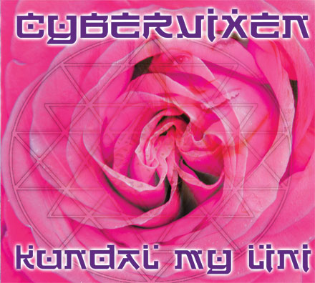 |  | RELEASE NOTES  "Kundal My Lini", the ecstatic new album from Cybervixen, is a playful, stylish, sweeping soundscape dancing skillfully between a fusion of genres - drawing influences from breakbeat, trance, world music, and DJ culture. This collection weaves well crafted songs with sensual exotic rhythms and poetic, uplifting and sophisticated vocals which embrace spirit and the divine. All tracks are gilded with shimmering FX and lush production on this cosmic dance journey. Album length - 9 tracks / 68 minutes  Joie Favier - Vocals, Co-Production, Lyrics and Concept.  Alex Newman - Production/Mixing, Programming, Keyboards  Kenji Williams - Violin Performances  Artist Profile:  Joie Favier's music communicates into the heart, riding the rhythm on the electronic dance musical wave.... Singer, Composer and DJ, Ms Favier has worked with multi-platinum producer Trevor Horn (Seal, Grace Jones, Art of Noise) as a solo artist signed to his label ZTT. She has recorded at world reknowned studios such as Abbey Road and Pink Floyd's Brittania Row. Current releases on S.F.'s Ceiba Records include: "Miditation, Digital and Peaceful", "Visitation" (DVD) and "Cybervixen - Looking Back From The Future". Recent live performances include Earthdance Festival, Anon Salon's "Sea of Dreams" Ball, Fusion Festival, Burning Man Festival, SF Love Parade and the "Digital Be-In". Cybervixen and her songs have also appeared in the underground cult feature film "Liquid Crystal Vision".  Alex Newman is the producer and keyboardist for the renowned electronic dance acts Medicine Drum and Alcyone. He has toured the USA and performed internationally playing keyboards, and he produced / co-wrote Medicine Drum's most recent album "Original Face", described by Billboard Magazine as "A major thrill." He composed the "Prayer for Peace", which is played annually at over 100 international locations simultaneously by DJs at Earthdance International, the world's largest synchronized music and dance festival.  Kenji Williams is an award winning electronic music producer, filmmaker, and classically-trained violinist. His first ever "Illusion" EP release reached a global audience of nearly 100,000 in collaboration with John Digweed's Bedrock label. He has had tracks released on top labels such as Flying Rhino and Interchill, and his full length tech-house, tech-trance album "Faces of Epiphany" has been internationally acclaimed. Kenji Williams latest project, DVD release "WORLDSPIRIT" a collaboration with world famous spiritual artist Alex Grey.  Label Profile:  Morningstar is a subdivision of Geomagnetic Records. Uplifting, melodic, progressive and perfect for those ecstatic moments of sunshine and awakening, the Morningstar label knows you want to be carried on a cloud of feel-good grooviness as you welcome the morning light!  Geomagnetic.tv was established in the summer of 2001.  Based in San Francisco and focusing mostly on visual and music related projects, you can expect to see lots more cutting edge releases on the way from this award winning crew! Geomagnetic.tv was started by Spook co-founder of prominent San Francisco 3D FX and Multimedia boutique Minds Eye Media.  www.mindseyemedia.com
Title: | Kundal My Lini
Artist: | Cybervixen
Label: | Geomagnetic.tv/ Lightstar
Catalogue: | GEOCD011
Format: | 4-Panel Digipak Audio CD
Barcode: | 9366977745186
Release: | August 27th World Wide
TRACK LIST
1. 'Land of Mystery' (mp3) Mystical, exotic trance with tablas, violin, driving dance rhythms and Sanskrit / English vocal incantations.
2. 'Fuel' (mp3) Uplifting, breakbeat electronica with soaring vocals and stunning percussion.
3. 'Ondine' (mp3) London breakbeat meets Celtic faeries in this uniquely ancient / modern 'song of the siren'. Cinematic!
4. 'Krystal' (mp3) Infectious mid-tempo groove meets lush production and evocative vocal.
5. 'Mists Of Time' (mp3) Epic, transcendental, nu-ambient with lyrical violins and sensual vocals inspired by the Damanhurian Temples of Humankind.
6. 'For Every Nation' (mp3) Deep club groove with stylish piano and soulful vocal invokes world peace.
7. 'Seratonin' (mp3) Housey and euphoric, with cascading synths and blissed out vocals.
8. 'Valley Of The Moon' (mp3) A poetic song about the Burning Man Festival set to a musical landscape of sexy, undulating rhythms, deep bass and elegant piano: this really takes you there!
9. 'Jupiter Wave' (mp3) Sizzling Tech-House with cosmic vocal... very DJ-friendly.
CREDITS
Mastered by Alex Newman Artwork by Arcane
Distribution by Saiko Sounds
(p) and © Geomagnetic.tv
http://geomagnetic.tv/releases/KundalMyLini
.htm info@geomagnetic.tv

