ENGRAMS 1: Luminaria 2012 CD – Geomagnetic.tv

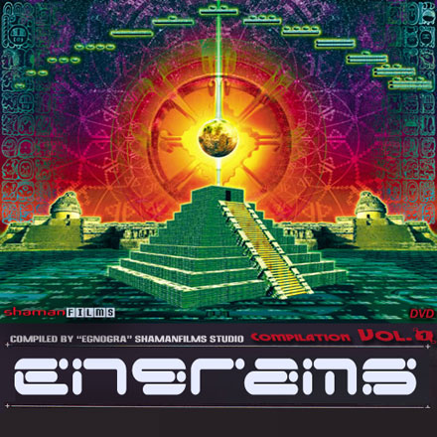 |  | RELEASE NOTES  Shaman Films presents its debut compilation co-released with Geomagnetic.tv. Engrams 1: Luminaria 2012 showcases 10 different creative visionaries visual interpretation of the process of transition to the time of 2012. The videos are set to special selected tracks that embody the essence of this theme. Together the videos tell a tale of galactic awakening and the transcendence of the physical limitations of this dimension. The artists creating the audio tracks represent the pinnacle of the international dark psytrance masters and were chosen for their intensity and clarity of the message. The visual artists are span all edges of the globe and each is noted as being the master of their region and their artform. Mastering by Chromatone Waveworks, Audio Engineering by Random.  Label Profile:  Geomagnetic.tv was established in the summer of 2001 and is a member of BMI Incorporated.  Their first major international release was the legendary DVD project “MAGNUS” geodvd001. Based in San Francisco  and focusing mostly on visual and music related projects,  you can expect to see lots more cutting edge releases on the way from this award winning crew! Geomagnetic.tv was started by Spook one of the founders of the prominent San Francisco 3D FX and Multimedia boutique known as Minds Eye Media (est.1995). www.mindseyemedia.com  Artist Profile:  DJ/VJ Doctor Spook Geomagnetic.tv (San Francisco, USA)  Also known as Nathan Vogel, Spook is an award winning  3D animator and music video director. He began creating  psychedelic visuals in 1992, receiving critical acclaim for  all of his projects. Nathan has worked with major music labels such as Arista, Geffen/Universal, Sony, Om and now with all of the most prominent Psy-trance labels with ground breaking new releases. Spooks passion for electronic music drove him to start making music in 1990. He began DJing Psy-trance at the Burning Man festival in 1998.  VJ/DJ Egnogra - Shaman Films (San Francisco, USA)  Compiled this groundbreaking cd and dvd. More info on him can be found on line at www.egnogra.com/bio.html  ENGRAMS is presented as a 2 part release with the CD being available in digipak format before the dvd. The DVD includes bios for both audio and video artists as well as VJ loops of each video and a loop all option as well. The DVD is encoded in 6.5mbps 24p AC-3 for maximum quality.
Title: | ENGRAMS1: Luminaria 2012
Artist: | VJ Egnogra - Various Artist
Label: | Geomagnetic.tv
Catalogue: | jap GEOCD005, eu SHAMFCD002
Format: | 4-Panel Digipak Audio CD
Barcode: | 9366977745070
Release: | April 24th World Wide
TRACK LIST
01. ELECTRYPNOSE vs YABYUM
FREEZE FILE
02. PENTA
LADY BUG
03. WIZARD LIZARD
BEAT CRASHER
04. MUBALI
LUMINARIA
05. OCELOT
KICK-START
06. N3XUS
CHINESE DEMON
07. HORROR PLACE
SAMAYA
08. XYLA
NOSTALGIA
09. PARAHALU
VAMPIRE - D
10. VAZIK
THE MESSAGE

CREDITS
Mastered by Chromatone
Artwork by Amani Friend and Egnogra
Distribution by Saiko Sounds
And Geomagnetic.tv Distribution
(p) and © Geomagnetic.tv
http://www.geomagnetic.tv/releases/engrams1.htm
info@geomagnetic.tv

