META “EKSTASIS” Debut Album (META formerly AEON) – ACIDANCE/DARKSTAR

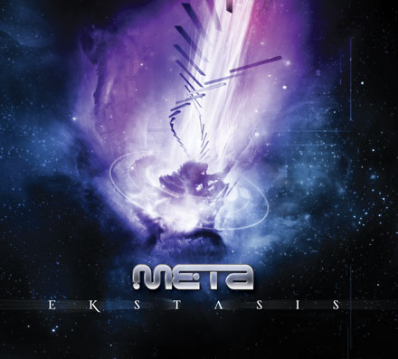 |  | RELEASE NOTES  META (Formerly known as AEON) is one of the best kept secrets of Psytrance in the USA. No new comer to making dancefloors go insane and beg for more DJ Aeon started djing in the mid 90s during the birth of the GOA TRANCE movement. With years of experience discovering just what makes the dancefloor tick he went to work refining his sound. For years he produced secret sizzlers that he wouldnt share till one day all the elements were perfect. From that point on DJ AEON became no more and META was born into this universe. Each track is finely tuned with resonance and harmonic frequencies into a symphony of clean and pristine ultra mayhem. Layer by meticulous layer was crafted taking the genre of "DARK PSYTRANCE" and turning it on its head. This journey into the unknown takes you from edge of the cosmos to the other by traversing the scales in bassline melodies that will tie your legs into pretzels as you redefine what it means to "dance" to trance music. Take a trip you will never forget and beg to return to again and again in this formula defying, genre expanding, mind exploding adventure for the senses. Prepare yourself to experience this full power, uber twisted, mega mental, drenched in acid, with a pumped up bassline that sends shivers up your spine and deep pulsating vibrations through your booty. To top it off the humor laced philosophical questioning of the universe if always woven in gracefully telling the listener a subtle story amidst the maelstrom of madness swirling around outside your eyelids.  META: (Greek: = "Beyond"), A concept which is an abstraction from another concept.  EKSTASIS: (Greek: to be outside oneself) A category of altered states of consciousness or trancelike states in which an individual transcends ordinary consiousness and as a result has a heightened capacity for exceptional thought.  Artist Profile:  Label Profile:  Acidance was founded in 1999 in Athens, Greece with the mission to present cutting edge dark trance to the world. Since then Acidance has earned the reputation as the leading dark trance label and has debuted a respectable number of artists such as Neuromotor, Parasense, Earthling, Digital Talk, Disassociative, Fungus Funk, and now Meta, who are now unanimously considered “top names” in the international scene.  Geomagnetic.tv was established in the summer of 2001.  Their first major international release is the legendary DVD  project “MAGNUS” geodvd001. Since then they have added 30 label artists and have multitudes of projects in the works for 2006 and beyond. Based in San Francisco and focusing mostly on visual and music related projects,  you can expect to see lots more cutting edge releases on the way from this award winning crew! Geomagnetic.tv was started by Spook one of the founders of the prominent San Francisco 3D FX and Multimedia boutique known as Minds Eye Media (est.1995). www.mindseyemedia.com
  META [formerly known as Aeon] , a Santa Cruz California resident, is one of the best kept secrets in the psytrance world for some time now. His DJ sets turn any dance floor into an inferno from the beaches to the biggest clubs to burning man to private parties at the legendary trance mansion. Aeon's signature style of hard yet clean psytrance gives all the tracks he produces a professional and wicked sensibility. His production sound is the envy of many with clear sounds and crystal sharp quality. Keep an ear to the dance floor for his new releases, they will not disappoint!!!
Title: | EKSTASIS
Artist: | META
Label: | Acidance / DARKSTAR
Catalogue: | ACIDCD019 / GEOCD019
Format: | 4-Panel Digipak Audio CD
Barcode: | 9366977745612
Release: | Feb 2007 World Wide
TRACK LIST

1. TRAVELING
2. THE EQUATION
3. ACCELERATION
4. BLARGSPOT
5. BOING!
6. ETIENNE – DARK MAGIC (META RMX)*
7. SUPER SNIZZY
8. AMORPHOUS (ALBUM RMX)
9. ARABEING
10. METAMANX – TURN MY HEADPHONES UP **

* w+p with Etienne Grunevald
** w+p with Dave Clark (aka DJ Manx)

CREDITS
Mastering @ Geomagnetic Studios by:
Chromatone and Random
Artwork by Subtrakt
Distribution by Saiko Sounds / CrystalCode
(p) and © www.Geomagnetic.tv
http://geomagnetic.tv/releases/META-Ekstasis.htm
info@geomagnetic.tv Hi-Res art online.

