PSYCHOZ – PSYCHOTIC EPIPHANIES (3rd Album) – GEO – DARKSTAR

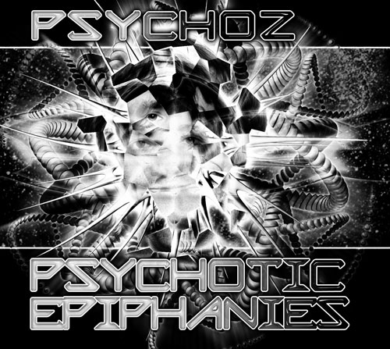 |  | RELEASE NOTES  To have such a wonderful realization that you appear to be psychotic to others who don’t understand your euphoric transcendence. These are the PSYCHOTIC EPIPHANIES that you will experience when you finally ignore your fears and doubts and let go. Let go and be taken by the power and primordial force that wells up inside of you and forces you to let out a savage scream and howl to the full moon. Then dance with movements that have been coded into your DNA. Tap into the hidden secrets that are written in your very fibres while going out of your body listening to this mind warping sound track to the death of your old self and the birth of your new. Crawl out of your skull and leave behind the world you once thought you knew and create a new definition of sanity. Psychoz will be your background growl while your brain goes on overdrive being overwhelmed by wave after wave of pure raw madness. This is the madness of the modern world filtered through Zoran’s skewed perspective on reality. Indulge in 9 wicked wacky and wild audio vortexes. Psychoz has toured the dance floors of the world finding all the right pockets of perversion to purvey his penultimate precision. These tracks are best heard at high volume and with no neighbors around. May the dancefloors tremble!  PSYCHOTIC: Psychotic alterations of perception are referred to as hallucinations; Persons experiencing a psychotic episode may experience hallucinations.  EPIPHANY: (Greek: επιφάνεια, "the appearance; miraculous phenomenon") (feeling), a realization or comprehension of the essence or meaning of something or someone; Great joy and transcendence, usually accompanied by new knowledge.  Label Profile:  Geo - Darkstar is the sub-label of Geomagnetic that focuses on Dark, Night time music, with hard, intense and experimental styles.  Geomagnetic.tv (Label Group) was established in the summer of 2001.  Their first major international release is the legendary DVD  project “MAGNUS” geodvd001. Since then they have added 30 label artists and have multitudes of projects in the works for 2006 and beyond. Based in San Francisco and focusing mostly on visual and music related projects,  you can expect to see lots more cutting edge releases on the way from this award winning crew! Geomagnetic.tv was started by Spook one of the founders of the prominent San Francisco 3D FX and Multimedia boutique known as Minds Eye Media (est.1995). www.mindseyemedia.com
  Zoran Zlatkovski aka Psychoz began creating psy-trance in the late 90`s. He is actually the first Macedonian psy-producer. His first EP release "Jupiter"(PMG Recordings) saw the light of the day end of 2000. 2002 followed his second release with 11 tracks on his self titled album on Avatar Rec. Psychoz`s been working for a while with an experimental side-project called WHITE TEETH which has released a CD for Macedonian label Lithium Records. Another new album is released January 2006 under Trishula Records sub-label. His style is very unique and has elements from dark,psy,twisted,forest,experimental, industrial and other variation forms of psy-trance.
Title: | PSYCHOTIC EPIPHANIES
Artist: | PSYCHOZ
Label: | GEO - DARKSTAR
Catalogue: | GEOCD024
Format: | 4-Panel Digipak Audio CD
Barcode: | 9366977745667
Release: | June 2007 World Wide
TRACK LIST

1- The Beginning RMX
2- Confession
3- Hell Razor
4- Death Is No Escape
5- Darkness Is Coming *
6- During As Instead Of
7- New World
8- Unchosen Path
9- Psychotic Epiphanies

*Vs Aditya Arora aka Violent

CREDITS
Mastering @ Geomagnetic Studios by:
Ross (Random) Dubois
Artwork by Doctorspook
Distribution by Arabesqe/ Saiko Sounds / CrystalCode
(p) and © www.Geomagnetic.tv
http://geomagnetic.tv/releases/Psychoz-PsychoticEpiphanies.htm info@geomagnetic.tv Hi-Res art online.





