RANDOM: Implicate Order CD – Geomagnetic.tv

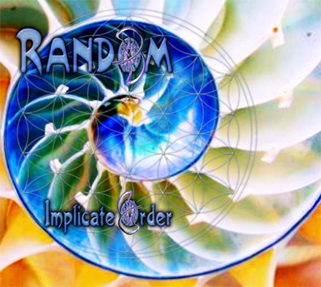 |  | RELEASE NOTES  Random is the at the front of the pack of PSYTRANCE artists coming from the highly anticipated hot bed in the USA, SAN FRANCISCO. He has toured the US extensively testing his music on dance floors and festivals, clubs and outdoors, night time and day. His flavor is ripe for the harvest and the music is perfectly seasoned for maximizing your pleasure centers! Not only has this genius of the psychedelic wizardry been zapping packed dance floors silly but he has been doing it for many years both as one of the Bay Areas first GOA/PSY Djs (Flawless mixing is his trademark) but also as one of the pioneering projects Producing and releasing music as early as 2001! The world is ready for this dance floor sensation to storm you into bliss!!!  Random also co-produces tracks under the titles: "CHROMATONE and RANDOM", "PHOENIX FAMILY" and "MEGADROP".  Label Profile:  Geomagnetic.tv was established in the summer of 2001.  Their first major international release is the legendary DVD  project “MAGNUS” geodvd001. Since then they have added 30 label artists and have multitudes of projects in the works for 2006 and beyond. Based in San Francisco  and focusing mostly on visual and music related projects,  you can expect to see lots more cutting edge releases on the way from this award winning crew! Geomagnetic.tv was started by Spook one of the founders of the prominent San Francisco 3D FX and Multimedia boutique known as Minds Eye Media (est.1995). www.mindseyemedia.com  Artist Profile:  Ross DuBois (aka RANDOM) began DJing in 1996. He started writing Psytrance music in 2000. Known for cpnstantly maiking music that kidnaps the listeners mind and sends it spiralling across frequency and time. His unique sound in intelligent, crunchy, groovy and mind expanding. Random has 14+ tracks out on 8+ compilations on Acidance, Shiva Space Technology, Spun., Timecode Kagdilla, Vaporvent and many more. This artist is skyrocketing to the top and has finally been unleashed!
Title: | RAMDOM – Implicate Order
Artist: | RANDOM Artist Album
Label: | Geomagnetic.tv
Catalogue: | GEOCD004
Format: | 4-Panel Digipak Audio CD
Barcode: | 9366977745094
Release: | Mar 24th World Wide
TRACK LIST
01. THE IMPLICATE
02. INURED
03. LIFE & EVERYTHING
04. INTENTIONALITY
05. PERSONAL GAME
06. EVIL WORDS
07. COSMIC PUZZLE
08. 13 AGAIN RMX
09. THE EXPLICATE

CREDITS
Mastered by Chromatone Waveworks
Artwork by Doctor Spook and Random
Distribution by Saiko Sounds
(p) and © Geomagnetic.tv
http://www.geomagnetic.tv/releases/Random_ImplicateOrder.htm info@geomagnetic.tv

