“SVJ1 – SPUN ON EARTH” DVD (VJ MIXMAGIK SERIES)
Presented by: Spun Rec / Geomagnetic.tv

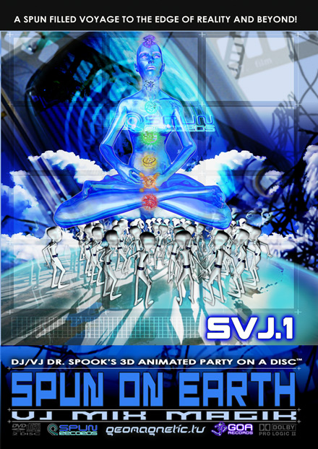 |  | RELEASE NOTES  At last! The worlds most popular trance artists together with one of the planets most celebrated psychedelic animators present 12 amazing 3D FX videos perfectly synched to the biggest hits! Each spectacular video abducts you on a SPUN filled journey into Dr. Spook's vivid and exotic imagination set to a fusion of acid techno, deep tribal beats and progressive tunes known worldwide as “GOA” or “Psychedelic” Trance. Spun Records and GeoMagnetic.tv, leaders of this unique art form proudly step forward with this revolutionary DVD. Spun was the 1st to bring Psytrance to Hollywood, the Superbowl broadcast, Sony's Grand Turismo games and now a worldclass achievement with this DVD/CD. Spook has worked with the biggest labels like Arista, Sony, Geffen, Universal, Elton John (Rocket Man Rec), Allman Brother's (Peach Rec), Cartoon Network/Adult Swim, featured in Res Fest and won multiple international awards. Experience Dr. Spook’s mind mending full power art adventure in Dolby AC3 Pro Logic Surround Sound.  - This DVD is a Complete Party on a Disc  - DJs, VJs, Clubs love seamless looping visuals  - Hi Res 7 Mbs 24fps 480P Mpeg2 video Encoding  - Awesome Dolby AC3 Pro Logic Surround Sound  - Made with Oscar Winning animation technology  - Compatible with all regions worldwide  - Bonus Mix CD with full indexed soundtrack  Artist Profile:   DJ/VJ Doctor Spook (San Francisco, USA)  Also known as Nathan Vogel, Spook is an award winning 3D animator and music video director. He began creating psychedelic visuals in 1992, receiving critical acclaim for all of his projects. Nathan has worked with major music labels such as Arista, Geffen/Universal, Sony, Om and now with all of the most prominent Psytrance labels with his ground breaking releases. Spook’s passion for electronic music drove him to start making music in 1990. He began DJing at Burning man in 1998. Recently Spook worked with Elton John to create 45 minutes of CGI HD footage for his 60th Birthday and 60th show at Madison Square Garden.  Label Profile:   Spun Records was founded by Seth Hoffmann, Bradd Hosking & G.M.S. (Growling Mad Scientists) in 1999, specializing in full on psytrance/out door party sound. It was decided by Seth & G.M.S. in July 2002 to open a European branch of the label in Ibiza (Spain) to increase the amount of releases and popularity of the label worldwide. sethspun@yahoo.com  Geomagnetic.tv (Label Group) was established in the summer of 2001. Their first major international release is the legendary DVD project “MAGNUS” geodvd001. Since then they have added 30 label artists and have multitudes of high end projects in the works for psytrance music and beyond. Based in San Francisco and focusing mostly on visual and music related projects, you can expect to see lots more cutting edge releases on the way from this award winning crew! Geomagnetic.tv was started by Spook one of the founders of the prominent San Francisco 3D FX and Multimedia boutique known as Minds Eye Media (est.1995). www.mindseyemedia.com www.myflik.com www.goa-records.com
Title: | SJV-1 SPUN ON EARTH
Artist: | Dr. Spook - Various Artist
Label: | Spun Rec / Geomagnetic.tv
Catalogue: | SPUNDVD002
Format: | 2-Panel 2disc Amarray Case
Barcode: | 881034184665
Release: | April 2008
http://video.google.com/videoplay?docid=-1539427242901049408
TRACK LIST
001:::... Deedrah
Goa Sunrise
002:::... Logic Bomb (aka Alternate Vision)
Theatre Of Magic
003:::... Eskimo
Open Your Eyes Up
004:::... Sub6 & Pixel
Navigate Into
005:::... Wrecked Machines, Domestic & Pixel
A.D.D.
006:::... Hallucinogen
Gamma Goblins (GMS RMX)
007:::... Skazi
Fire N Ice
008:::... Talamasca
Speaking Robot [GMS RMX]
009:::... Soundaholix (aka Earthling & GMS)
The Moon
010:::... Soundaholix
LSD Story [Infected Mushroom RMX]
011:::... Phoenix Family & Earthling
Killer Dope [Chromatone RMX]
012:::... Mindstorm (aka Doctor Spook)
Starstuff

CREDITS
Dist: Arabesque (Europe) Solstice Int. (Japan)
DVD Produced by Doctor Spook
Audio Engineering - Ross Dubois (Random)
Executive Producer - Seth Hoffman (p) and © Spun Rec / Geomagnetic.tv
www.geomagnetic.tv info@geomagnetic.tv
WWW.geomagnetic.tv/releases/svj1.htm
UPC code: 

