TRIP CONTROLLERS v/a by Doctor Spook – Geomagnetic.tv DARKSTAR

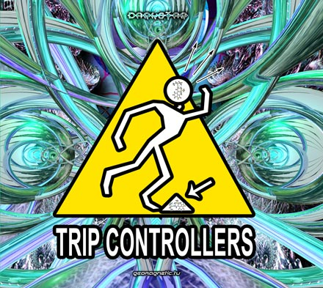 |  | RELEASE NOTES  TRIP CONTROLLERS is a THEME compilation that takes you on a journey from begin to end. The start of your journey ushers you into a fun filled adventure where your mind is the territory to be explored. You will find along the way that we have control of your senses for the duration and we will help you to Bust down those walls inhibiting your Brain. Using hi tech tools to induce the Electrical Activity to your cerebral pleasure centers. If you start to feel over whelmed Dont Panic! Taken by the power of realisation knowledge demands action Right Now! Awareness comes through delving deep through knowledge already attained by Recycling your Dreams to recall these blocked memories. By using this enhanced state of mind you attain Synchronisation with your body and spirt. Confronting your demons can be a Bad Trip but it must be done. Now the path to Eternal Happiness can be found. Twists and turns can bring unexpected memories suppressed by Traumatik Amnesia. Now you realize that the your outdated mental programing from your past is what is holding you back and that you are your own Trip Controller. 12 Demented Psychoacoustic Scientists from across the globe conspired together to take you on this journey of the mind you will never forget! Enjoy 10 specially formulated trips for your mind.  Label Profile:  Geomagnetic.tv was established in the summer of 2001.  Their first major international release is the legendary DVD  project “MAGNUS” geodvd001. Since then they have added 30 label artists and have multitudes of projects in the works for 2006 and beyond. Based in San Francisco  and focusing mostly on visual and music related projects,  you can expect to see lots more cutting edge releases on the way from this award winning crew! Geomagnetic.tv was started by Spook one of the founders of the prominent San Francisco 3D FX and Multimedia boutique known as Minds Eye Media (est.1995). www.mindseyemedia.com  Artist Profile:  Artist Profile:  DJ/VJ Doctor Spook (San Francisco, USA)  Also known as Nathan Vogel, Spook is an award winning  3D animator and music video director. He began creating  psychedelic visuals in 1992, receiving critical acclaim for  all of his projects. Nathan has worked with major music labels such as Arista, Geffen/Universal, Sony, Om and now with all of the most prominent Psy-trance labels with ground breaking new releases. Spooks passion for electronic music drove him to start making music in 1990. He began DJing Psy-trance at the Burning Man festival in 1998.
Title: | TRIP CONTROLLERS
Artist: | v/a compiled by Dr. Spook
Label: | Geomagnetic.tv DARKSTAR
Catalogue: | GEOCD012
Format: | 4-Panel Digipak Audio CD
Barcode: | 9366977745193
Release: | July 2006 World Wide
TRACK LIST
1. TWISTED REACTION - Brain Busters
2. TSABEAT vs SPAZZZ- Electrical Activity
3. WICKED WIRES vs BRAIN HUNTERS - Dont Panic
4. PSYCHOZ - Right Now
5. FREQTRIK - Dream Recycle
6. DISTORTED GOBLIN - Synchronisation
7. DARK FORCE - Bad Trip
8. ABANDONED NOISE - Eternal Happiness
9. AUDIOPATHIK - Traumatik Amnesia
10. GORUMP PEYYA - Trip Controller

CREDITS
Mastered by Chromatone Waveworks
Engineering by Random
Artwork by Doctor Spook
Distribution by Saiko Sounds
(p) and © Geomagnetic.tv
http://geomagnetic.tv/releases/TripControllers.htm
info@geomagnetic.tv Hi-Res art online.
