VECTRO ELECTRO : RASTA BLASTA (GEO – ISRAEL) a Division of Geomagnetic.tv

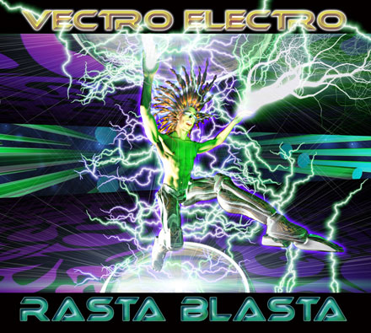 |  | RELEASE NOTES  Vectro Electro has just thrown the book away when it comes to formula. Blazing his own trails has always been a big part of Haim’s creative inspiration and with this totally new debut album he frees you from your mental asylum of conformity that has been gripping dance floors across the world. Vectro Electro opens the doors to a new world where party people are now free to redefine the status quo ruling over dance music today. From beginning to end you are treated to a new vision of psychedelic trance, full on, dark, totally mental, uplifting and even melodic in a refreshingly dissonant and surprisingly addictive way. Dance floors across the planet have reacted in explosions of blissful pleasure with each track having been proven in his exciting and creative live sets as well as by top DJs at festivals. Most important are the dancers who regard Vectro Electro as a pioneer bringing a new wave of style, production and creativity that translates into sounds that make your body electrified with life! Haim integrates the best of Electronic music styles such as drum & bass, electro, dance hall, trip hop, tech-punk and fuses them into a fresh new psychedelic trance variation that will never be forgotten. “Rasta Blasta will twist you like pasta and make you move fasta!”  Artist Profile:  Vectro Electro Haim Mitnitsky born in 1980 in the Ukraine. Living in Israel , started DJ'ing at the year 2000 (DJ Shanti Alien) and producing music since 2003 With the first releases (2004) He changed the name to Vectro Electro. He is well known in the non stop party scene in Israel , playing in lots of good parties delivering the people memories for a long time ahead. He focuses mostly on morning music, some darker some lighter. He is a full time student focused on upgrading his knowledge of music production. These days he is focusing on his 3rd year of sound studies, the first year he studied synthesis and now sound engineering. His Album RASTA BLASTA is nearing completion and previews will be ready soon!  Label Profile: www.geomagnetic.tv  GEO-ISRAEL is a subdivision of Geomagnetic Records, offering the most cutting edge sounds from the hottest new artists of the Israeli psychedelic underground. With no distinguishing night and day, day and night, GEO-Israel offers a thick, light, full-on and dark aural journeys to enhance your trance dancing experience!  GEOmagnetic.tv was established in the summer of 2001.  Their first major international release is the legendary DVD  project “MAGNUS” geodvd001. Since then they have added 30 label artists and have multitudes of projects in the works for 2006 and beyond. Based in San Francisco and focusing mostly on visual and music related projects, you can expect to see lots more cutting edge releases on the way from this award winning crew! Geomagnetic.tv was started by Spook one of the founders of the prominent San Francisco 3D FX and Multimedia boutique known as Minds Eye Media (est.1995). www.mindseyemedia.com
Title: | RASTA BLASTA
Artist: | VECTRO ELECTRO
Label: | Geo - Israel
Catalogue: | GEOCD020
Format: | 4-Panel Digipak Audio CD
Barcode: | 9366977745629
Release: | February 2007 World Wide
TRACK LIST
1. INTRO
2. SELECTA
3. MONSTER BASH
4. RELIEF
5. HYPER SAPIENS
6. BDBYEBYE
7. VECTROLIZE
8. POISON
9. JAGGERMEISTER (Guitar by ORCA)
10. ABVGDEIKA

CREDITS
Mastered by Ross (Random) Dubois @ Geomagnetic Studios - Sanfransicso
Artwork by Doctor Spook
Distribution: Saikosounds, Arabesque & Crystal Code
(p) and © GEO - ISRAEL (a division of Geomagnetic Records)
info@geomagnetic.tv Hi-Res art online:
http://geomagnetic.tv/releases/VectroElectro_RastaBlasta.htm



