WELLSPRING 1: EQUINOCTURNIS CD – Geomagnetic.tv

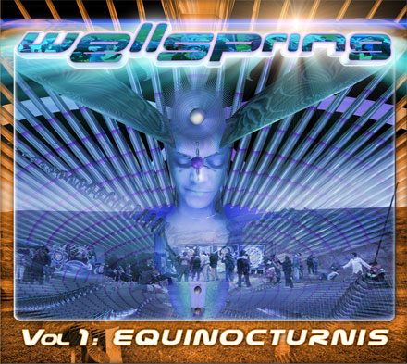 |  | RELEASE NOTES  Wellspring is a celebration of life, art and freedom. The theme of freedom is expression and joyous celebration. On the spring Solstice we traditionally start the outdoor party and festival season. Equinocturnis means equal night and we interpret it to remind us that the night is a very important time to gather together and form community in preparation for the year to come, embodied in the form of the sacred dance circle. This compilation represents the music from the artists that perform at these ritual celebratory expressions of our faith in the cosmos for the eternal regeneration of the life process. Affirming our belief through action is the most powerful symbol to the universe. These sacred musical expressions presented here are harmonically tuned to create maximum mind - body, mental -physical and psychic cleansing through ecstatic dance and dynamic meditation. Doctor Spook compiles these 10 dynamic aural meditations forming vol1 of this epic series.  Label Profile:  Geomagnetic.tv was established in the summer of 2001.  Their first major international release is the legendary DVD  project “MAGNUS” geodvd001. Based in San Francisco  and focusing mostly on visual and music related projects,  you can expect to see lots more cutting edge releases on the way from this award winning crew! Geomagnetic.tv was started by Spook one of the founders of the prominent San Francisco 3D FX and Multimedia boutique known as Minds Eye Media (est.1995). www.mindseyemedia.com  Artist Profile:  DJ/VJ Doctor Spook (San Francisco, USA)  Also known as Nathan Vogel, Spook is an award winning  3D animator and music video director. He began creating  psychedelic visuals in 1992, receiving critical acclaim for  all of his projects. Nathan has worked with major music labels such as Arista, Geffen/Universal, Sony, Om and now with all of the most prominent Psy-trance labels with ground breaking new releases. Spooks passion for electronic music drove him to start making music in 1990. He began DJing Psy-trance at the Burning Man festival in 1998.  Audio CD Format 10 Previously Unreleased Psy-trance Morning Stormers by the best of the West Coast Psy-Trance Producers: Penta, Chromatone & Helios, Ocelot, The Loomi, Bodhisattva, , Deeper in Zen. Look for Random’s stunning Album “IMPLICATE ORDER” coming out on GEOMAGNETIC.TV Spring 2006. Geomagnetic.tv is proud to debut some of the hottest new projects coming from San Francisco:  AEON – Look for his incredible new artist album coming out on Geomagnetic.tv Spring of 2006!  MINDSTORM – The most eagerly anticipated new producer coming from SF is Dr. Spook’s new project.
Title: | Wellspring1: Equinocturnis
Artist: | Various Artist
Label: | Geomagnetic.tv
Catalogue: | GEOCD006
Format: | 4-Panel Digipak Audio CD
Barcode: | 9366977745087
Release: | May 12th World Wide
TRACK LIST
1. CHROMATONE vs HELIOS - New Conciousness
2. THE LOOMII - Freak Factory
3. MINDSTORM - Psybernetic
4. QUADRA - Vibrations
5. PENTA - Blue Xmas
6. AEON - There For- Party
7. RANDOM - 13 Again
8. BODHISATTVA 13:20 - Gung Fu Trippers
9. DEEPER IN ZEN - Trancendelia
10. ROB-OT - 1995

CREDITS
Mastered by Chromatone
Artwork by Doctor Spook
Distribution by Saiko Sounds
(p) and © Geomagnetic.tv
http://www.geomagnetic.tv/releases/wellspring1.htm
info@geomagnetic.tv


