GRATEFUL DANCE v/a by DJ TROYAN – Geomagnetic.tv DARKSTAR

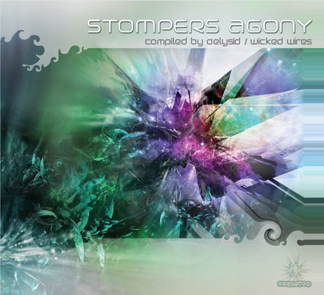 |  | RELEASE NOTES  Delysid aka WickedWires has been raging around the world for the past year and ended up in the hot bed of South American Psytrance, Brazil! With tons of big parties under their belt playing as either of their super wild live acts or doing epic dj sets of featuring tons of unreleased tunes from close and far they finally slowed down enough to compile these 9 super stormers into a cohesive flow and the results are devastating! The bass can be heard for miles and the energy is just exploding causing you to dance so hard and uncontrollably that your body aches and your mind is reeling! Grab your stretcher or wheel chair and put it near by because you will need to be carried away from the dance floor (or your living room) when you are done! As if that was not enough Doctor Spook, renowned label manager for Geomagnetic Label Family has graciously contributed one special unreleased extra hit from rising star META coming from his NEW full length album next month..! Prepare yourself for an epic journey into STOMP as you writhe and twist your way into this vibrational ecstatic playground of the senses. Enjoy this DARK and ROWDY treat from the Labels that never cease to amaze with their sensational and timely deliveries: ACIDANCE and GEO-DARKSTAR.  Artist Profile:  Label Profile:  Acidance was founded in 1999 in Athens, Greece with the mission to present cutting edge dark trance to the world. Since then Acidance has earned the reputation as the leading dark trance label and has debuted a respectable number of artists such as Neuromotor, Parasense, Earthling, Digital Talk, Disassociative, Fungus Funk, and now coming soon Meta, who are now considered “top names” in the international scene.  Darkstar is the Darktrance focused sub-label of the Geomagnetic label family. Dedicated to finding the best of the worlds hard, dark, nighttime flavoured music that is known to cause dance floor explosions! Prepare your self for a mind expanding experience for the body and soul…  Geomagnetic.tv was established in San Francisco, the summer of 2001.  Their first major international release is the legendary DVD  project “MAGNUS” geodvd001. Geomagnetic.tv was started by Spook one of the founders of the prominent San Francisco 3D FX and Multimedia boutique known as Minds Eye Media (est.1995). www.mindseyemedia.com
  MENOG vs AUDIALIZE – With This track these two front line maniacs conquer your fears of dancing beyond your endurance. You get a second wind after dancing to this strong and inspirational kicker. RANDOM receives a resounding applause for managing to come after the last track and build us up for a solid session. KHOPAT twists us that much further with a gripping crescendo near the middle that launches us into a frenzy.
  TRYAMBAKA has a sense of humor that never ends and this track does not let you down. A real anthem epic that just goes up.
  TOXIC lets loose with the real gem on this dose of fresh vibes. I think this one is the hit so look out!!! A really funny sample starts it off. SICK ADDICTION proves that there is no way to kick your addiction once you start to listen to this cd! DELYSID the stars who compiled this full on surprise winter mega hit with the title track to trip you out! WICKED WIRES vs BRAIN HUNTERS have come together again to deliver us the peak of the experience!!!
  META (fomerly known as AEON) – This track sneaks up on you from a distant universe and then scoops you up and flies away!!!
Title: | STOMPERS AGONY
Artist: | v/a compiled by Delysid
Label: | Acidance / DARKSTAR
Catalogue: | ACIDCD018 / GEOCD018
Format: | 4-Panel Digipak Audio CD
Barcode: | 9366977745469
Release: | Nov 2006 World Wide
TRACK LIST

01-MENOG vs AUDIALIZE - Mental Reproduction
02-RANDOM - Bifurcation
03-KHOPAT - Come Closer
04-TRYAMBAKA - Stroke of Luck
05-TOXIC - Mofos in Da House
06-SICK ADDICTION - Today's Madness
07-DELYSID - Stompers Agony
08-WICKED WIRES vs BRAIN HUNTERS - Mr Mars
09-BRAIN HUNTERS - Genetic Poison
10- META (fomerly known as AEON) - Boing! [ BONUS TRACK ]
CREDITS
Mastered by Random @ Geomagnetic Studios
Artwork by Doctor Spook
Distribution by Saiko Sounds & Geo-Distro
(p) and © www.Geomagnetic.tv
http://geomagnetic.tv/releases/StompersAgony.htm
info@geomagnetic.tv Hi-Res art online.
