Tricossoma – Psychosomatic Reorder EP – GOAEP003 – Goa Records/Geo-Darkstar

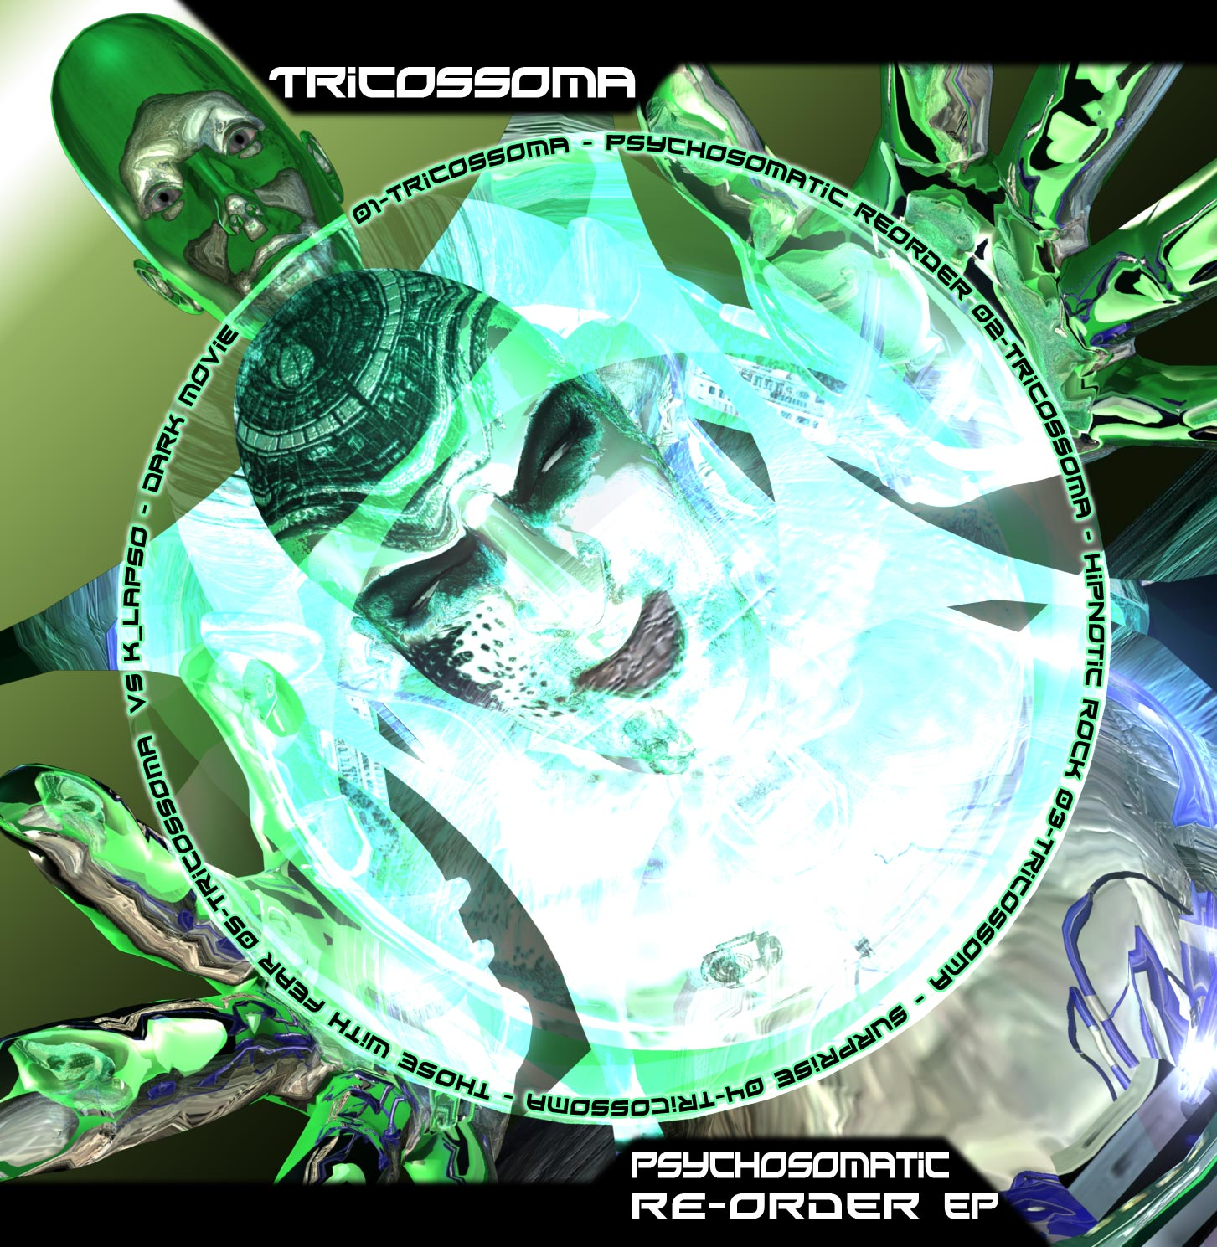 |  | RELEASE NOTES:  Tricossoma – Psychosomatic Reorder EP  Psychosomatic Reorder is the latest full power offering from Portuguese artist and native Luis Palma aka Tricossoma. Expect lots of insane tracks from this bad boy of beats! Tricossoma's new Psychosomatic Re-order EP is just what the doctor ordered to give you that mental upgrade that also gives alittle kick in the butt to keep your booty bumpin till morning.  Artist Profile:  Luis Palma was born in Serpa(Portugal) in 1981 and he's AKA Tricossoma. He lived in Serpa till he was 22, he then moved to Tomar in 2004. It was in Tomar that he came in contact with Fruity loops/ Cubase / Ableton everything he needed to produce electronic music. He always liked electronic music, ever since he heard it for the first time. Since then he became particularly interested in Psychedelic Trance. Some time later he developed his own technics resulting in his first released track "Voices From Darkness" which came out November 2006 in the compilation VA-Digital Drugs-Vol1 by Geomagnetic Recs.Look out for his upcoming 5 track Digital EP "Psychosomatic Reorder" that will redefine your idea of rippin night time trance!  Label Profile:    Goa Records is a new label founded in 2006 based in California/USA. Focused on finding the very best of the worlds leading psy-trance and goa-trance hits and compiling these into a highly commercialized package suitable for mainstream distribution outlets. Expect a steady stream of high quality, cutting edge releases from this already amazingly popular new label.  Geo - Darkstar is the sub-label of Geomagnetic that focuses on Dark, Night time music, with hard, intense and experimental styles. Geomagnetic.tv (Label Group) was established in the summer of 2001. Based in San Francisco and focusing mostly on visual and music related projects, you can expect to see lots more cutting edge releases on the way from this award winning crew! Geomagnetic.tv was started by Spook one of the founders of the prominent San Francisco 3D FX and Multimedia boutique known as Minds Eye Media (est.1995). www.mindseyemedia.com
Title: | Psychosomatic Reorder EP
Artist: | Tricossoma
Label: | Goa Records and Geo-Darkstar
Catalogue: | GOAEP003
Format: | 1 Panel Insert Audio CD & DDL
Barcode: | 881034279149
Release: | Nov 11th 2008
TRACK LIST

1.Tricossoma - Psychosomatic reorder
2.Tricossoma - Hipnotic rock
3.Tricossoma - Surprise
4.Tricossoma - Those with fear
5.Klapso vs Tricossoma - Dark movie
CREDITS:
MASTERED BY: Mastering by Mauricio Avendaño @ Ovnimoon Studios, Santiago of Chile
Artwork by: Doctor Spook
Distribution: Ingrooves & Goa-Records
(p) and © Geomagnetic.tv
info@geomagnetic.tv More info online.
http://geomagnetic.tv/labels/Goa-Records/GOAEP003-Tricossoma



