GOA–Cytopia 1 goarec003/4 - 2 CD V/A by Prahlad, Servellen and Dr. Spook – GOA RECORDS

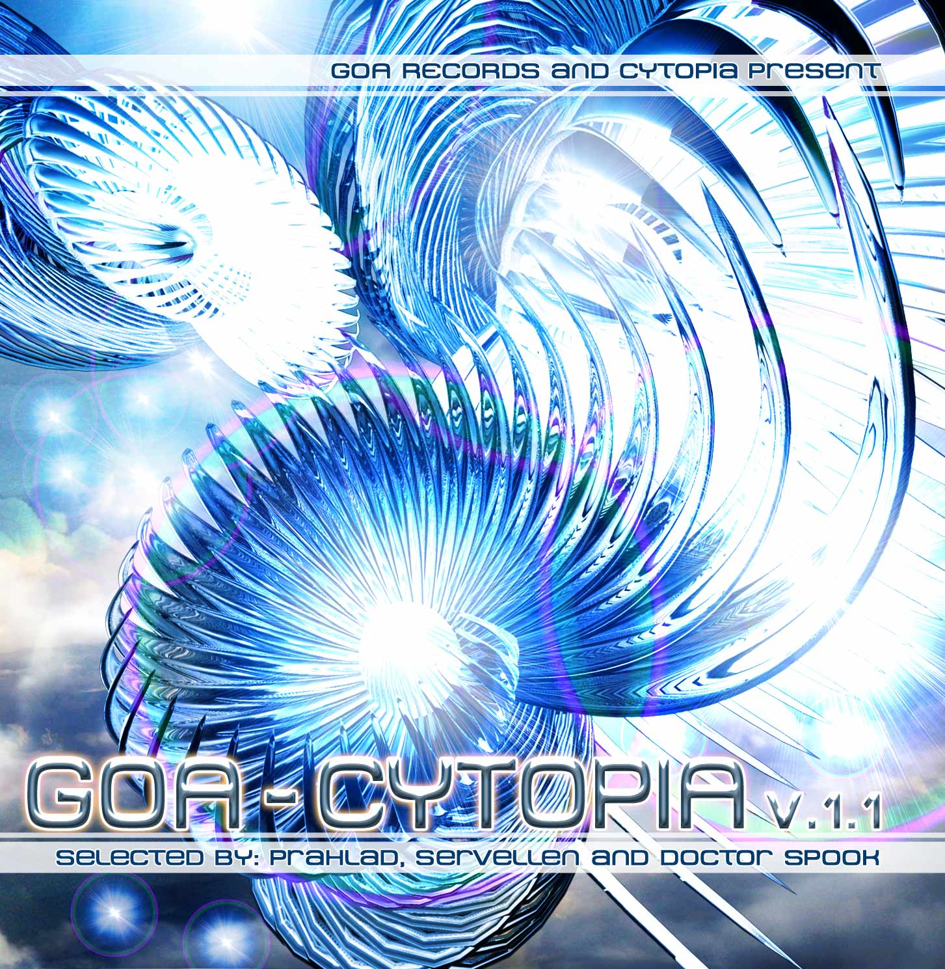 |  | RELEASE NOTES: Goa Cytopia 1.1 + 1.2  GOA Cytopia Vol. 1.1 + 1.2 presents two amazing CDs full of the winning selections from the 2008 Cytopia Artist Competition. Prahlad, Servellen and Doctor Spook presided as judges of the event and these 20 top finalists were compiled out of over 150 different artists from around the globe. Memorable samples, heartfelt melodic hooks, full power raging bass lines, original compositions and fresh new musicians who have been practicing their styles on their local dance floors across the planet all combine to create the perfect refreshing dose of life. Two totally packed CDs present 20 truly memorable and moving tracks that will be making you yell out for more. This cross section of the planets winning masters and new wizards of Goa Trance and Progressive Psychedelic Fullon as well as two special psy-chill producers offers a real world glimpse into the magic and mystery that is felt each weekend at secret parties around the planet held on beaches, forests, mountain tops, deserts and indoors at warehouses, yoga/dance studios, and living rooms. Now you can have a piece of these underground phenomena and relive the excitement that this experience conveys. Welcome to the Goa Trance Experience.  Artist Profile:  Prahlad (Germany, YSE) has released an amazing album (YSE) and several great singles on many different label's compilations. Strong melodic and emotional content is his specialty  Servellen (Amsterdam, Cytopia) Also known as Sander van Servellen, has been managing Cytopia.org digital download site and label since 2004. Intense experiences of passion for Dancing at Goa trance parties 1996 – 2000 inspired Sander to be involved in composing and performing music and innovating the Cytopia.org concept.  DJ/VJ Doctor Spook (San Francisco, Goa Records) Also known as Nathan Vogel, Spook is an award winning 3D animator and music video director. He began creating psychedelic visuals in 1992, receiving critical acclaim for all of his projects. Nathan has worked with major music labels such as Arista, Geffen/Universal, Sony, Om and now with all of the most prominent Psy-trance labels with ground breaking new releases. Spooks passion for electronic music drove him to start making music in 1990. He began DJing Psy-trance at the Burning Man festival in 1998.  Label Profile:  Goa Records is a sub-label of Geomagnetic Records founded in 2006 based in California/USA. Focused on finding the very best of the worlds leading psy-trance and goa-trance hits and compiling these into a highly commercialized package suitable for mainstream distribution outlets. Expect a steady stream of high quality, cutting edge releases from this already amazingly popular new label.  Cytopia.org (Cytopia Records) is the leading Goa psytrance shop specializing in digital download shop on the market today. New and amazing released & unreleased tracks can be found at the Cytopia.org website every week with a large variety of labels and artists.
Title: | Goa-Cytopia 1 + 2
Artist: | v/a by Prahlad, Servellen, Dr. Spook
Label: | Goa Records / Cytopia.org
Catalogue: | GOAREC003 + GOAREC004
Format: | 4-Panel Jewel Case Audio 2CD
Barcode: | 881034098535 & 881034184719
Release: | September + October 2008
TRACK LIST

101 - Sonitus Maku - Unsane Visions - 133
102 - Frost Raven - Tabula Rasa - 135
103 - Leenuz - Red Eye Warrior - 137
104 - Bratex - Nightshot - 140
105 - Gaiana - Universe Alive (Kernavemoon Rmx) - 142
106 - Te-Tuna - Hallissa - 145
107 - Virtual Light - Castlevania - 145
108 - Reactive - Midnight Express - 145
109 - Static Nation - Shiga On! - 143
110 - Bandarlog - The Wizzard Of Oz - 115

201 - Organix - The Blade - 134
202 - Bassid - Too Far - 142
203 - Sufi - Playground (Getafix Rmx) - 144
204 - Neuroimpact - Alone - 145
205 - Highpulse - Ibiza - 146
206 - Tuk - Failure To Communicate - 145
207 - Reactive - Quake Is Fake - 145
208 - Pantarei - You Are Free - 145
209 - Psigh - Lullaby - 142
210 - The Inharmonic Orchestra - Spiritual Peace – 90

CREDITS:
Artwork by: Doctor Spook
Mastered by Prahlad + Servellen @ Bitstream Studio
Compiled By: Servellen, Prahlad and Doctor Spook
Distribution by Saiko Sounds, Psyshop, Geomagnetic
(p) and © Cytopia, Goa Records, Geomagnetic.tv
info@geomagnetic.tv More info online.
geomagnetic.tv/labels/Goa-Records/GOAREC003-Goa-Cytopia1.1
geomagnetic.tv/labels/Goa-Records/GOAREC004-Goa-Cytopia1.2


